**Report - JishiBuilding Guide**

·Student name: Lin Juekai

·Student id: 2253744

·Tutor: Ying Shen

**1.Assignment description**

Make a guide APP on the 4th floor of the Building. Users can visit each room on the 4th floor of the Building in the system to understand the use of each room and the personnel in the room.

requirement:

1.Provide an overview of all rooms on the 4th floor of the Building;

2.Users can quickly select a room to view;

3.Support the key sub-query:such as search element:student work office or Gelei.

**2.Interface presentation**

My JishiBuilding navigation system interface is as follows:

**·Overview part**

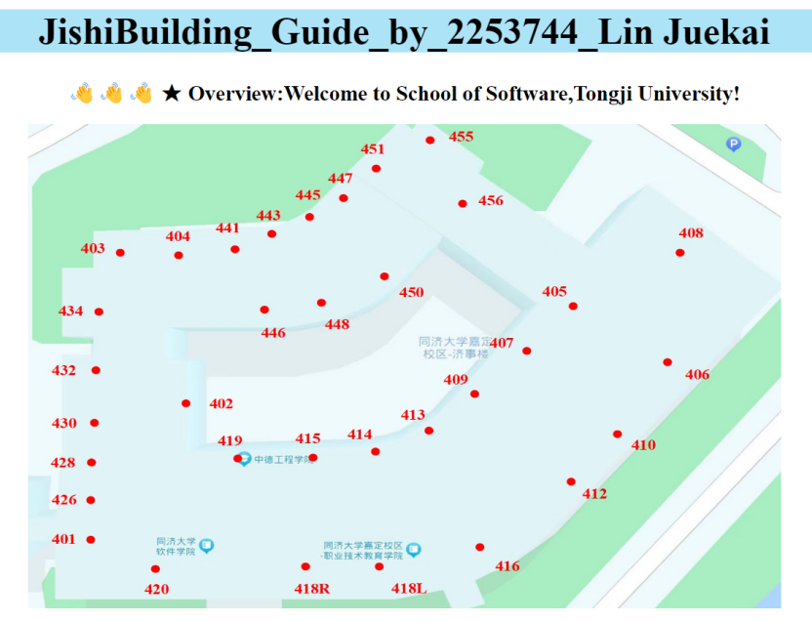

picture 2.1 The overview part

At the top part of the page is the overview section of this navigation page. I obtained the plan of the building from the Scott map, scaled it appropriately, and marked above the location of each of the rooms below in the actual order. This is a static overview image that completes the first point of a given assignment requirement:.Provide an overview of all rooms on the 4th floor of the Building.

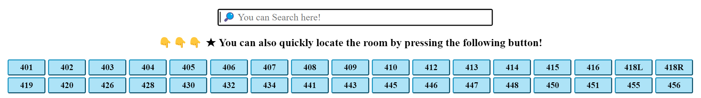**·Retrieval part**

picture 2.2 The retrieval part

In the middle of this navigation page is the retrieval part, we can enter the keyword information in the search box, such as the name of the teacher, the number of the room, the name of the room and the actual use of the room, etc. We can also press the button of the quick room number below to locate and retrieve the room we need.This section completes the third requirement in this assignment:Support the key sub-query:such as search element:student work office or Gelei.See below for the specific use methods.

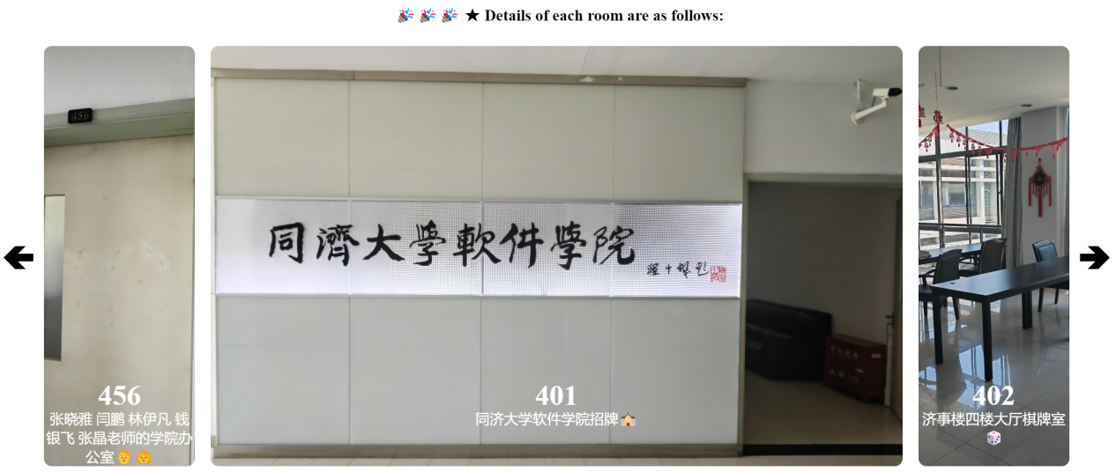**·Details part**

picture 2.3 The details part

The third half of the navigation page shows the specific situation of each room, including the picture of each room(this is I on May 28,2024 in the afternoon and May 31,2024 in the evening after field photos), each room number and each room specific information(such as the room is used for what, what is the room teacher, etc.). This section completes the second requirement of the navigation page assignment:Users can quickly select a room to view.Of course, users can also enter the corresponding room number in the search box or click the according clickbuttons to quickly find the room you want, as we will see below.

**3.Designing explanation**

The purpose of Fluid navigation is to provide a user-friendly and efficient user interface interactive experience. The specific objectives include: improve the availability, which requires complete navigation functions; enhance the user experience, which requires the navigation image to make the user feel in reality; improve efficiency, which requires to optimize the navigation path, minus unnecessary buttons and processes, so that the user can have a complete navigation experience. Next, I will analyze the design principle and inspiration idea of my Jaid building navigation page from the perspective of a user.

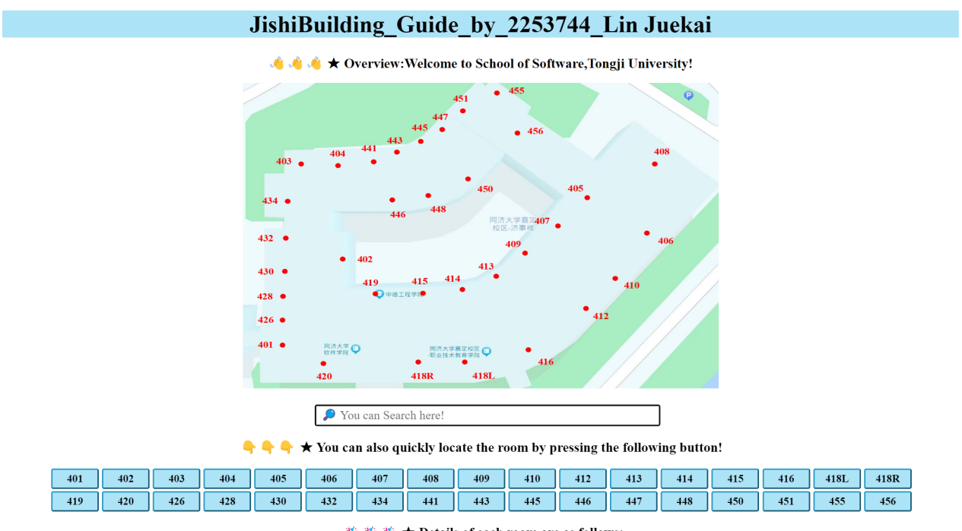First, you visited my navigation page, and you saw the welcome sentence and the obvious page block design, which can perfectly reflects the availability and effectiveness in Fluid navigation.

picture 3.1 The overall page

As soon as you come to this page, you can see the floor plan of the fourth floor, which can let you have a better overall understanding of the fourth floor. At this time, you will be curious, the overall layout is so, then what about every room?

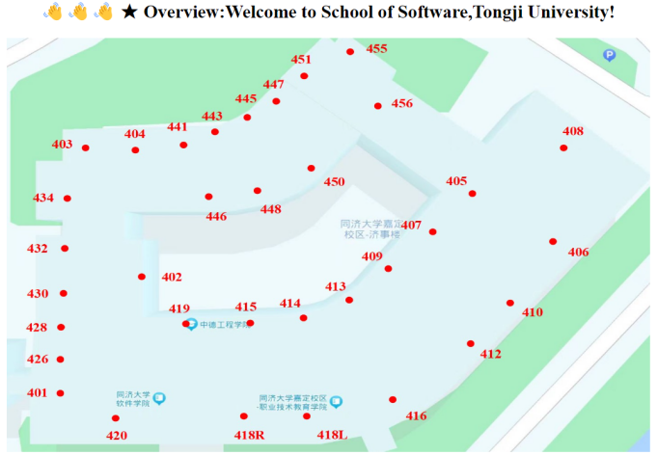

picture 3.2 have a better overall understanding of the fourth floor

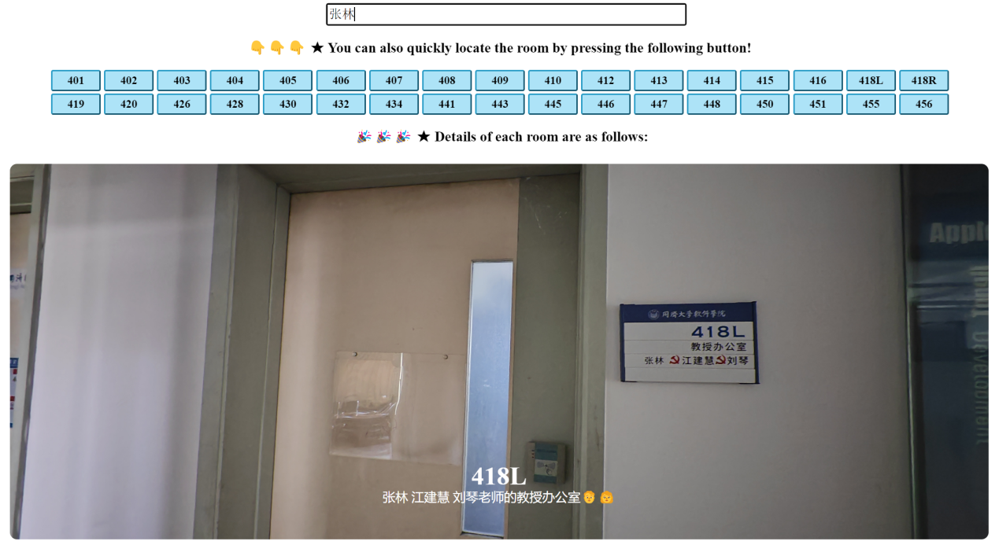Then you go to search mode, where you're curious to see the information about each specific room, so you can enter the corresponding keywords in the search box.For example, below, search for “张林”:

picture 3.3 keywords search

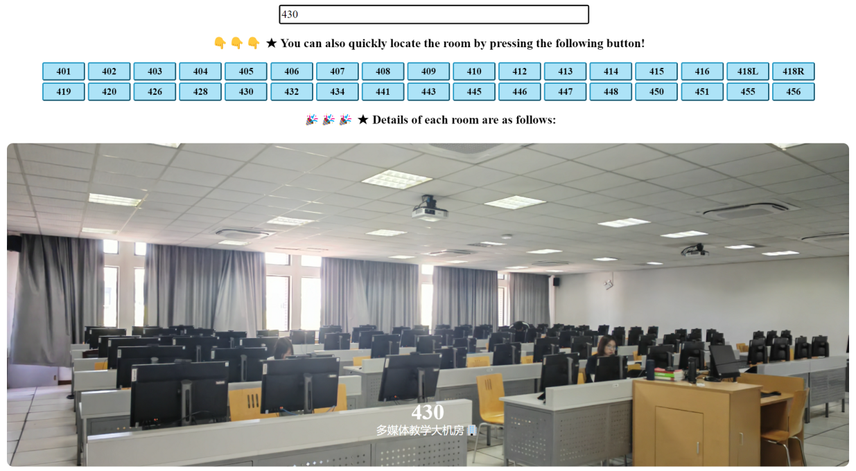Of course, you can also enter the corresponding room number for a search.For example, below, search for 430:

picture 3.4 room number search

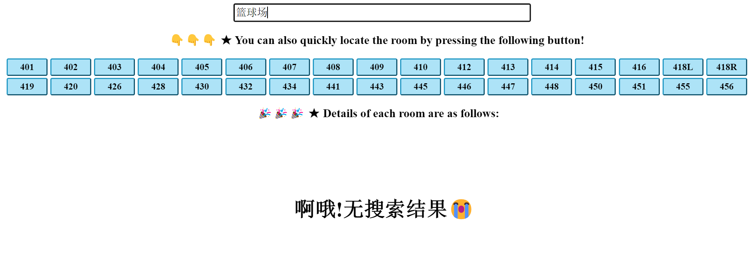Of course, the prompts will jump out when you can't search for the content.For example, below, search for “篮球场”:

picture 3.5 no search results

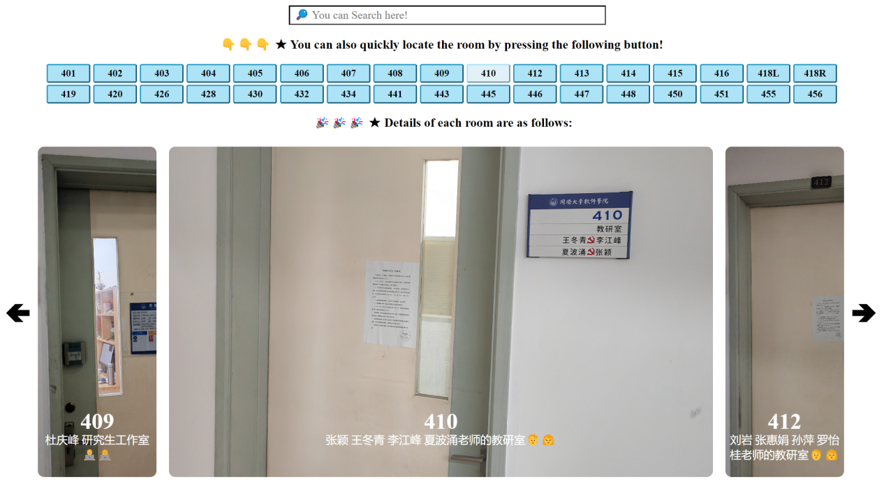If you want to locate each classroom more quickly, you can also use the shortcut button below, click the button of the room number you want, and the picture in the middle below will immediately jump to the room information you need.For example, below, click the button “410”:

picture 3.6 shortcuts key to locate the room

Then there's the part of the specific picture. Users can not only view the following pictures through the above operation, but also directly view the pictures of

each room. As shown below, the initial picture in the middle is the sign of 401 Software Institute, there are two buttons on both sides, the pictures of each room are 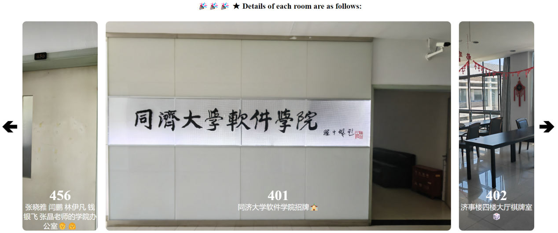arranged in order, press the left arrow to jump to the previous picture, press the right arrow to jump to the latter picture. This method also allows users to view specific information about each room in order to achieve this effect “Fluid navigation”.

picture 3.7 view of the specific room pictures

rightArrow

leftArrow

Ok, that's all the features and content of my navigation web design.My concept is to try to make users feel the sense of hierarchy, simplicity and convenience. The sense of hierarchy is reflected in the general part, the search part and the display part are distinct, the order is different, so that the user can visit the buttons and icons in the page, but in the style of the blue style, the function of the web page, to view the specific content of the picture, users can keyword search, can press the shortcut button and order view, there are many ways to view the specific information of each room of the building, so it is convenient.This navigation page provides users with a smooth viewing process, clear key Settings, a variety of selection viewing methods and order of the navigation process to satisfy Fluid navigation principle.

**4.My feelings and gains**

Through this homework, I have gained a lot. Personally, I think I have gained two aspects: First, I have more mastered the use of the three musketeers at the front end, including many key trigger types and container Settings; Second, I have a more detailed understanding of the floor plan of JishiBuilding, so it will be more convenient for me to go to the college to find a teacher (ha ha ha).

Finally, thanks to teacher for providing us with such an interesting homework!